

National Textile University
Department of Computer Science
Subject
Mobile Application Development

Submitted to:
Sir Rehan Servar

Submitted by:
Abdul Rehman Sudais

Registration Number
23-NTU-CS-1123

Lab
08

Semester
6th

Execution:
- Insert your actual API key into weather_service.dart .
- Run the app ( flutter run ).
- You should see a loading spinner briefly, followed by the current temperature, city name, and condition for London

TASKS:
WEATHER SERVICES (CODE)
import 'dart:convert';
import 'package:http/http.dart' as http;
import 'weather_model.dart';

class WeatherService {
// Replace with your actual API key
static const String apiKey = '4f438a841d96bfdb774d939f1841e95c';
// Using London's coordinates as default for the lab
static const double lat = 51.5074;
static const double lon = -0.1278;

Future<Weather> fetchWeather() async {
// We add &units=metric to get Celsius instead of Kelvin
final url = Uri.parse(
'https://api.openweathermap.org/data/2.5/weather?lat=$lat&lon=$lon&appid=$apiKey&units=metric');
final response = await http.get(url);
if (response.statusCode == 200) {
// Parse the JSON data
final jsonResponse = jsonDecode(response.body);
return Weather.fromJson(jsonResponse);
} else {
throw Exception('Failed to load weather data');
}
}
}

WEATHER MODEL (CODE)
class Weather {
final String cityName;
final double temperature;
final String description;
Weather({
required this.cityName,
required this.temperature,
required this.description,
});
// Factory constructor to parse JSON
factory Weather.fromJson(Map<String, dynamic> json) {
return Weather(
cityName: json['name'],
temperature: json['main']['temp'].toDouble(),
description: json['weather'][0]['description'],
);
}
}

MAIN.DART (CODE)
import 'package:flutter/material.dart';
import 'weather_model.dart';
import 'weather_service.dart';

void main() {
runApp(const WeatherApp());
}

class WeatherApp extends StatelessWidget {
const WeatherApp({super.key});

@override
Widget build(BuildContext context) {
return MaterialApp(
debugShowCheckedModeBanner: false,
home: const WeatherScreen(),
);
}
}

class WeatherScreen extends StatefulWidget {
const WeatherScreen({super.key});

@override
State<WeatherScreen> createState() => _WeatherScreenState();
}

class _WeatherScreenState extends State<WeatherScreen> {
final WeatherService service = WeatherService();
late Future<Weather> weatherFuture;

@override
void initState() {
super.initState();
weatherFuture = service.fetchWeather();
}

void refresh() {
setState(() {
weatherFuture = service.fetchWeather();
});
}

@override
Widget build(BuildContext context) {
return Scaffold(
appBar: AppBar(
title: const Text("Weather App"),
actions: [
IconButton(
icon: const Icon(Icons.refresh),
onPressed: refresh,
)
],
),
body: Center(
child: FutureBuilder<Weather>(
future: weatherFuture,
builder: (context, snapshot) {

if (snapshot.connectionState == ConnectionState.waiting) {
return const CircularProgressIndicator();
}
else if (snapshot.hasError) {
return Text("Error: ${snapshot.error}");
}
else if (snapshot.hasData) {
final w = snapshot.data!;
return Column(
mainAxisAlignment: MainAxisAlignment.center,
children: [
Text(w.cityName,
style: const TextStyle(fontSize: 30)),
Text("${w.temperature} °C",
style: const TextStyle(fontSize: 50)),
Text(w.description,
style: const TextStyle(fontSize: 20)),
],
);
}

return const Text("No Data");
},
),
),
);
}
}
OUTPUT:
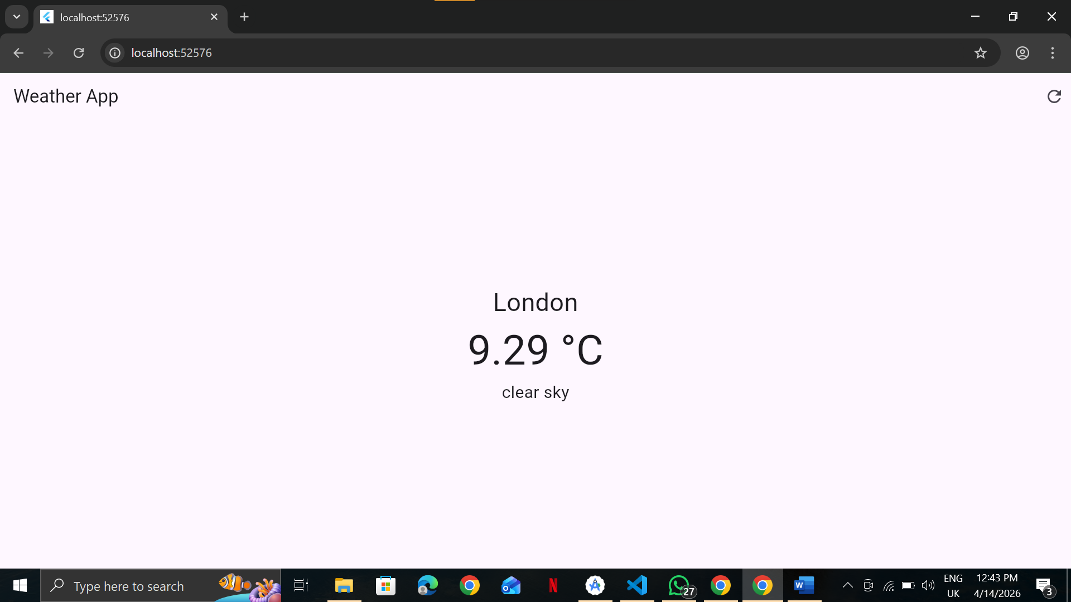

Bonus Challenges for Students:
Challenge 1 (Dynamic Inputs): Instead of hardcoding lat and lon in the fetchWeather method, add a Flutter TextField so the user can input the latitude and longitude dynamically and press a button to search.
Challenge 2 (Geocoding API): The OpenWeather API documentation recommends using their Geocoding API to turn a City Name into Lat/Lon. Create a two-step API call where the user types "New York", the app fetches the Lat/Lon using the Geocoder endpoint, and then fetches the weather.
Challenge 3 (UI Enhancement): Use the icon string returned in the JSON ( json['weather'][0]['icon'] ) to display the official OpenWeatherMap icon in the UI using Image.network('https://openweathermap.org/img/wn/{icon_code}@2x.png') .

MAIN.DART:
import 'package:flutter/material.dart';
import 'weather_model.dart';
import 'weather_service.dart';

void main() {
runApp(const WeatherApp());
}

class WeatherApp extends StatelessWidget {
const WeatherApp({super.key});

@override
Widget build(BuildContext context) {
return MaterialApp(
debugShowCheckedModeBanner: false,
home: const WeatherScreen(),
);
}
}

class WeatherScreen extends StatefulWidget {
const WeatherScreen({super.key});

@override
State<WeatherScreen> createState() => _WeatherScreenState();
}

class _WeatherScreenState extends State<WeatherScreen> {
final WeatherService service = WeatherService();

final TextEditingController cityController = TextEditingController();
final TextEditingController latController = TextEditingController();
final TextEditingController lonController = TextEditingController();

Future<Weather>? weatherFuture;

void searchByCity() {
if (cityController.text.isNotEmpty) {
setState(() {
weatherFuture = service.fetchWeatherByCity(cityController.text);
});
}
}

void searchByLatLon() {
if (latController.text.isNotEmpty && lonController.text.isNotEmpty) {
setState(() {
weatherFuture = service.fetchWeatherByLatLon(
double.parse(latController.text),
double.parse(lonController.text),
);
});
}
}

@override
Widget build(BuildContext context) {
return Scaffold(
appBar: AppBar(title: const Text("Weather App")),
body: Padding(
padding: const EdgeInsets.all(16),
child: Column(
children: [

// 🔹 CITY SEARCH
TextField(
controller: cityController,
decoration: InputDecoration(
hintText: "Enter City (Lahore)",
border: OutlineInputBorder(),
suffixIcon: IconButton(
icon: Icon(Icons.search),
onPressed: searchByCity,
),
),
),

SizedBox(height: 10),

// 🔹 LAT/LON INPUT
TextField(
controller: latController,
decoration: InputDecoration(
hintText: "Latitude",
border: OutlineInputBorder(),
),
),

SizedBox(height: 10),

TextField(
controller: lonController,
decoration: InputDecoration(
hintText: "Longitude",
border: OutlineInputBorder(),
),
),

SizedBox(height: 10),

ElevatedButton(
onPressed: searchByLatLon,
child: Text("Search by Lat/Lon"),
),

SizedBox(height: 20),

// 🔹 RESULT
Expanded(
child: Center(
child: weatherFuture == null
? const Text("Enter data to search")
: FutureBuilder<Weather>(
future: weatherFuture,
builder: (context, snapshot) {

if (snapshot.connectionState ==
ConnectionState.waiting) {
return const CircularProgressIndicator();
}
else if (snapshot.hasError) {
return Text("Error: ${snapshot.error}");
}
else if (snapshot.hasData) {
final w = snapshot.data!;
return Column(
mainAxisAlignment: MainAxisAlignment.center,
children: [

Text(w.cityName,
style: TextStyle(fontSize: 30)),

// 🔥 ICON (Challenge 3)
Image.network(
"https://openweathermap.org/img/wn/${w.icon}@2x.png"
),

Text("${w.temperature} °C",
style: TextStyle(fontSize: 50)),

Text(w.description,
style: TextStyle(fontSize: 20)),
],
);
}

return const Text("No Data");
},
),
),
)
],
),
),
);
}
}

OUTPUT:
